Montoursville Presbyterian Church
900 Elm Street, Montoursville, PA
October 2, 2016 8:15am & 10:45am
World Communion Sunday
God’s People Gather
Please observe prayerful silence when the prelude begins.
WELCOME AND OPENING PRAYER
PRELUDE “Trust And Obey” Stewart Landon

LIGHTING OF THE CHRIST CANDLE/CHORAL INTROIT (10:45)
Glenna & Maynard Bogart

We Praise the Lord
*CALL TO WORSHIP (from Psalm 91)
L: Whoever dwells in the shelter of the Most High will rest in the shadow of the Almighty.
P: I will say of the Lord, “He is my refuge and my fortress, my God in Whom I trust.”
L: “Because he loves Me, “ says the Lord, “I will rescue him; I will protect him for he acknowledges my Name.
P: He will call on Me, and I will answer him; I will be with him in trouble,
L: I will deliver him and honor him.
P: With long life I will satisfy him and show him My salvation.”

*Hymn of Praise: 483 “Sing Praise to God, Who Reigns Above”

THE CONFESSION OF SIN
Call to Confession
Prayer of Confession
Merciful and gracious God, You sent Jesus Christ into the world not to condemn the world but that the world might be saved through Him. You have reached out to us in love, but we have turned from You and from one another. Take away our sin, heal our brokenness, and help us to turn back to Your life and Your love, given freely in Jesus Christ, our Savior and Lord. We ask this in His name, Amen. (Silent Confession)

Assurance of Pardon
*Response of Praise: 579 “Gloria Patri”

Passing the Peace
L: The peace of the Lord Jesus Christ be with you.
P: And also with you.

Hear God’s Word
CHILDREN’S LESSON
PRAYER FOR ILLUMINATION
THE LAW: Genesis 41:41-43 (pg. 44/63)

THE EPISTLE: 2 Corinthians 5:11-21 (pg. 1160/1757)

SPECIAL MUSIC (8:15) “On Eagle's Wings” Debbie Keller

CHORAL ANTHEM (10:45) “In Remembrance” Chancel Choir

THE GOSPEL: Luke 15:11-31 (pg. 1048/1592)

Leader: This is the word of the Lord! People: Thanks be to God!

SERMON Lost and Found Rev. David C. Smith

*Hymn of Response:
261 “God of Compassion, in Mercy Befriend Us”

*AFFIRMATION OF FAITH Nicene Creed (pg. 15)
The Disciples Give Thanks

THE PRESENTATION OF TITHES AND OFFERINGS
Offertory “Communion in Christ” Todd Kendall
*Doxology: 592 “Praise God, from Whom All Blessings Flow”
*Prayer of Dedication

INSTALLATION OF DEACONS –
Diane Haas & Rachael McCloskey
Hymn of Preparation: 501 “Bread of Heaven, on Thee We Feed”

THE SACRAMENT OF THE LORD’S SUPPER
Invitation to the Table
Prayer of Thanksgiving
Words of Institution
The Bread and Cup
Closing Prayer

THE SHARING OF JOYS AND CONCERNS Marc Haas

PRAYERS OF THE PEOPLE The Lord’s Prayer (pg, 16)

We Go Forth To Serve

ANNOUNCEMENTS

*Hymn of Sending: 366 “Jesus, Thy Boundless Love to Me”

*CHARGE AND BENEDICTION

POSTLUDE “Blessed Be The Lord God” Chester Nordman

*Please stand, if able

Worship Leaders Pastor: Rev. David C. Smith
Greeters & Ushers: (8:15) Steve Rush
Greeters: (10:45) George and Diane Casella
Ushers: (10:45) D. Weiser, N. Bixler, D. Peace, G. Casella Sr.
Liturgist: (8:15) Ellen Dunkleberger (10:45) Carl Fulton
Organist: Debbie Keller Guest Choir Director: Leatha Kieser

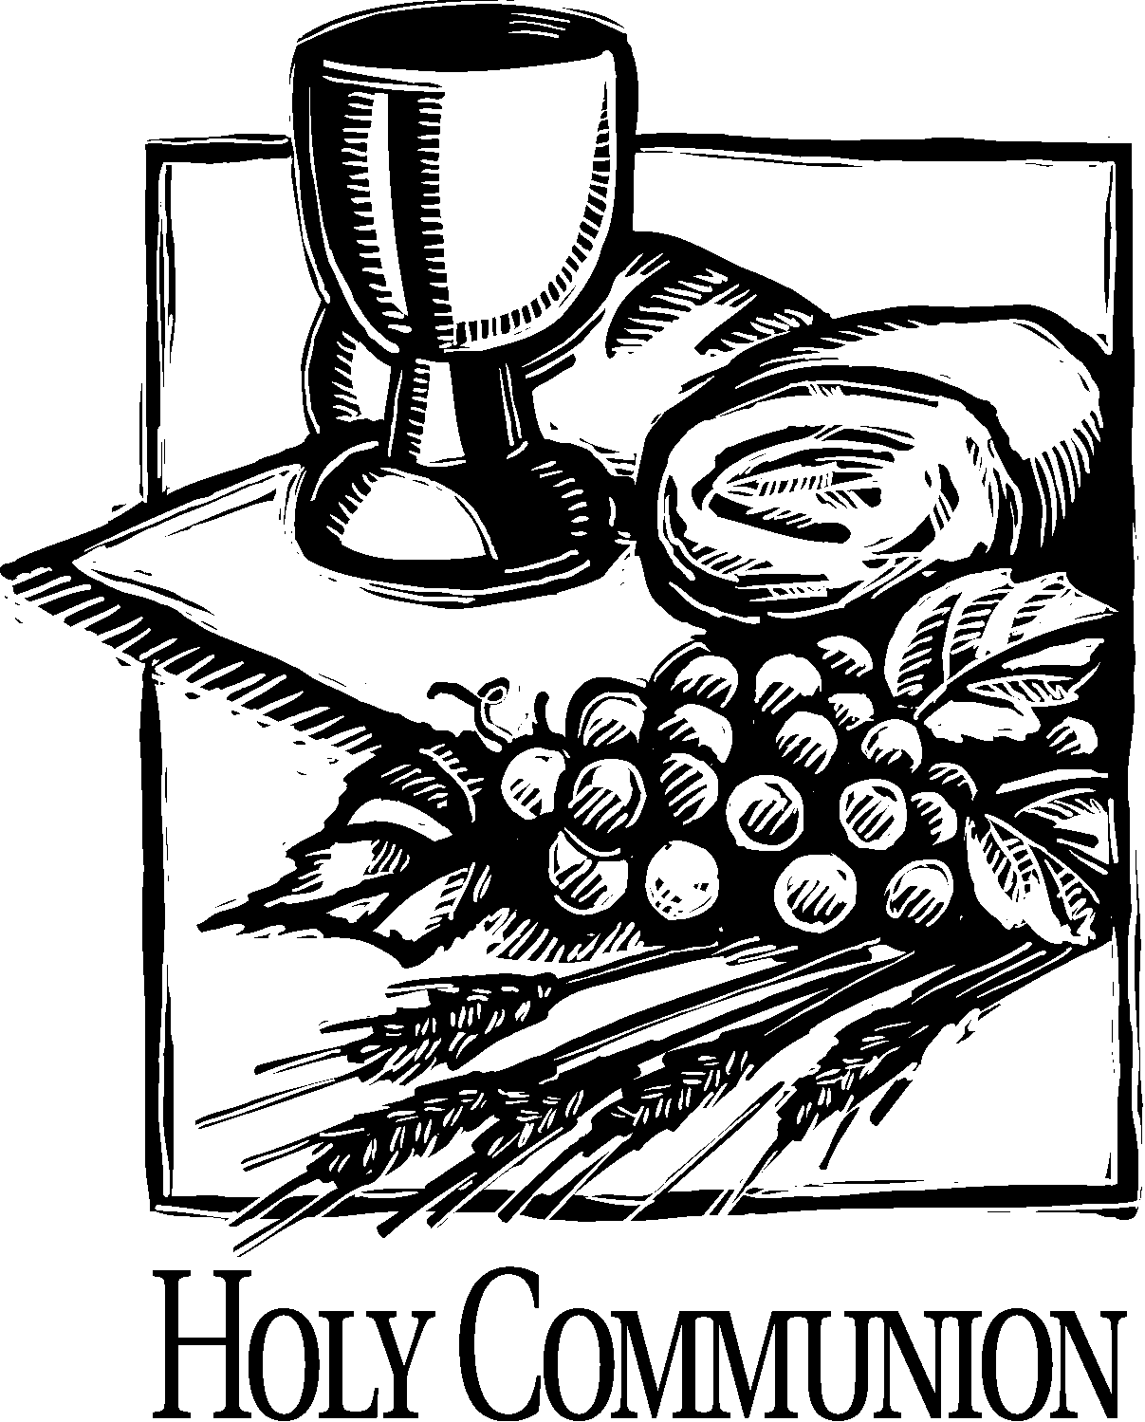

Montoursville Presbyterian Church
900 Elm Street
Montoursville PA 17754

This Week at MPC

Sunday, October 2nd World Communion Sunday
8:15am Worship Service (S)
9:15am Coffee Fellowship (FH)
9:30am Sunday School (C)
10:45am Worship Service (S)
Monday, October 3rd (Food Pantry/Shep. of the Sts. Delivery)
8:30am Prayer Group (MCEC)
2:00pm-4:00pm Circle 1 Meeting (FH)
Tuesday, October 4th (bulletin announcements due)
Wednesday, October 5th
6:30pm Worship Committee Meeting (MCEC)
Thursday, October 6th
1:00pm Garden Club (FH)
6:00pm Deacon Meeting (C)
6:15pm-8:15pm AA Meeting (FH)
Friday, October 7th
Office Closed
Saturday, October 8th
Sunday, October 9th
8:15am Worship Service (S)
9:15am Coffee Fellowship (FH)
9:30am Sunday School (C)
10:45am Worship Service (S)
5:30pm FISH Youth Group (MCEC)
S – Sanctuary C – Classroom FH – Fellowship Hall N – Nursery
MCEC – Mendenhall

Last Week’s Attendance: 8:15am – 36 10:45am – 104

Pastor’s Office (570) 368-4747 MontourPastor@verizon.net
Church Office: Mon-Thur 9:00-noon (570) 368-1595
E-mail: Montourpc@gmail.com Website: www.montourpres.org
Listen to David’s sermons at: http//www.youtube.com/user/montourpc

Announcements for the week of October 2, 2016
Welcome to the Montoursville Presbyterian Church
Visitors: Please complete a Visitor Card found in the pew rack and place it in the offering plate. If you are looking for a church home or membership, please see the Pastor, an Usher, or call the office.
To assist with your worship experience, we offer:
Personal hearing devices – please see an Usher
Pew cushions – stored above the coat racks in the Narthex
Large print hymnals – in the Narthex
Handicap/family restroom – off the far end of Fellowship Hall
Worship bags for children – in a basket in the Narthex
Nursery care for children ages up to 5 years old
Our nursery staff: Deb Rupert, Mary Strein, and Gaetan Casella

Today, we celebrate the Sacrament of the Lord’s Supper.
If you know of anyone homebound or not able to attend and would like to receive communion, please see the pastor or call the office.

FISH Youth Group
October 9 — Destination Unknown. Come to the MCEC at 5:30pm prepared for an adventure with $7 for dinner out afterwards.
October 23 — So what is the big deal about swearing? Is it a big deal? Come to the MCEC at 5:30 pm and find out (we hope!). Dinner provided.

MPC is seeking an individual to serve as Nursery Attendant. If you or someone you know may be interested, please contact Neil Bixler at 570-407-2126 or nbixler@live.com.
This is a compensated position.

Ushers and Greeters for October 23rd and October 30th
(8:15am) Ushers and Greeters: Marge Bieber & Betty Edkin
(10:45am) Greeters: Mike & Winnie Kremser
Ushers: J. LeCrone, K. Fenstermacher, M. Crist, I. Fox

Krislund’s Fall Festival
October 15
10:00am-2:00pm
Face Painting, Pumpkin Painting, Games, Crafts, Food, Build a Scarecrow, and more.
10:00-12:00 – Zip Line and Climbing Wall.
12:00-2:00 – Giant Swing
Each attendee will get one free adventure park ride;
additional activities can be purchased that day.
10:00 – Carpet Ball Tournament 12:00 – Corn Hole Tournament

Fall Gathering The PW Fall Gathering for the Presbyterian Women of Northumberland Presbytery (PWPN) is October 22 at the Montoursville Presbyterian Church. The program will be taken from Matthew 25:35, “For I was hungry and you fed me, I was thirsty, and you gave me drink, I was a stranger and you invited me into your home.” Registration will begin at 9:30am with the Worship Service at 10:00am. Guest speaker is Mona Rundio (from our church). She is the new director of United Churches Food Pantry. We are asking each person attending to bring a non-perishable item for the Williamsport Food Pantry.

Here is a list of our shut-ins. If anyone would like to send a card, or call or visit, it would be greatly appreciated.

Harriett Bernier 323-4340 (Main No) Rod Husted
Rose View Court, Lycoming Creek
1251 Rural Ave., Rm. 227 1445 Sycamore Rd., Rm 109
Williamsport, PA 17701 Montoursville, PA 17754

Doug Bird Elizabeth Maule 368-2909
Muncy Valley Assisted Living Elmcroft of Loyalsock
215 E. Water St., 2985 Four Mile Dr.,
Muncy Pa 17756 Montoursville, PA 17754

Audrey Dochter 368-1725 Frank Odell 433-3477
1610 Fairview Dr., 481 Odell Rd.,
Montoursville, PA 17754 Muncy Pa 17756

Lighting of the Christ Candle
October 9 – Diane and Marc Haas
October 16 – Sharon and Don King

Prayer List
Illness, recovery and support: David Albert, Kathy Butkofsky, Nancy Bergesen, Harriett Bernier, Marge Bieber, Doug Bird, Joann Bower, Barb Campbell, Hedi Campbell, Helen Cartwright, Diane Chestnut, Robert Bozart, Mary Christie, Andy Clayton, Derre Family, Audrey Dochter, Joanne Drake, Craig Dunkleberger, Danny, Jody and Noah Fagnano, Betty Farley, Ramona Fausey, Tad Fiser, Janine Fisher, Bob Folmar, Tim Garman, Gary Groff, Trista Hackenberg, Michelle Hackenberg, Tom Hoy, Rod Husted, Audrey Keiper, Liese Kimble, LeMerre family, Roberta Lombardi, Marrell family, Clayton Merrill, Jim Mexdorf, Miriam Miller, Gabe Newton, Buzz and Sandy Platt, Leigh Purdy, James and Shirley Shaner, Stella Walmer, Marieva Williams
Joys: Luann Frantz’s parents are doing well.
Irv and Margaret Fox’s 57th wedding anniversary.
Kim Ellison’s new grandson.

Military: Duane (DJ) Burleigh, Ryan Burns, Joe Cardone, Capt. Brady Cillo, Jessie Confer, Maj. Laurie Fontaine, Caleb Frantz, Julia Glosek, Ben Hepburn, Ethan Jones, Dani Kline, Sgt. J. Patrick Lawracy, Jeremy Loveland, David McCollin, Marissa Patterson, Paul Wenner
Others: Nthemba Church (Sister church in Africa), Ministries of MPC, Peace in the World, Camp Krislund, France, Flight 800 families, Italy, Flood victims in Louisiana.

